Military Institute of Science and Technology
Department of Computer Science and Engineering
Course Title: Data and Tele- Communication Sessional
Course Code: CSE-318, Cr. Hr: 1.50
Level-3, Term-2

Experiment No: 08

Name of the Experiment: ASK Modulation and Demodulation

Objectives:
The main objectives of this experiment are:
- To know the technique of digital amplitude modulation.
- To study the characteristics of a signal modulated in amplitude.

Required Equipments:
- MODICOM 5 Board
- IC Power 60 unit
- Set of connection leads
- Multi meter
- Oscilloscope
Theory:

In transmission by radio frequency, the data cannot be transmitted directly. In such cases, a high frequency carrier signal must be used. The simplest way to modulate a carrier with a data is to change the carrier signal amplitude each instance the data changes. The technique is called amplitude Shift Keying (ASK).

The simplest form of carrying out this modulation is to make the transmitter emit the carrier signal as long as the bit to be transmitted is a ‘1’ and to suppress it totally when this is a ‘0’, as can be seen in the following figure.

To generate an ASK signal, the transmitter uses a balanced modulator. This device simply multiplies the two signals at its inputs. The output voltage at any moment is the product of two input voltages. One of the inputs will be the carrier signal and the other is the data. See the following figure:

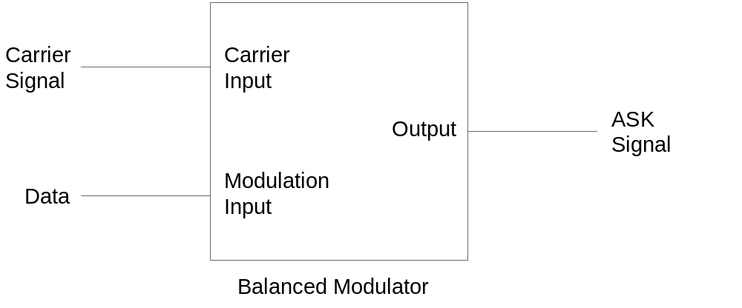

In the receiver the circuitry required to demodulate a signal of this type is minimal. The simplest method is to rectify the ASK signal and then to filter it. The signal is then passed through a voltage comparator and thus the output data is obtained. See the following figure:

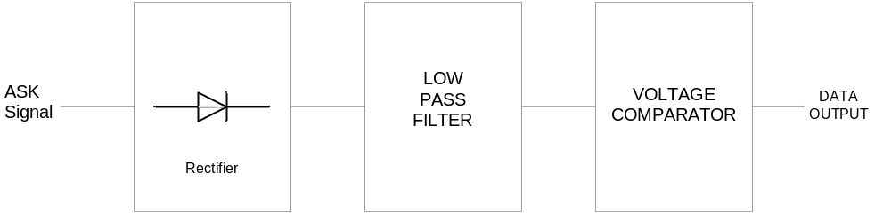

Modulator signal (Data): Adjusting the MODICOM 3/1 with the DC1, we should obtain the data:
D6………………………D0
1 0 1 0 1 0 1
The signal we shall use as modulator is that corresponding to the NRZ (L) codification of the said data.

PART A: ASK MODULATION

Procedure:

- Carry out the assembly indicated in the following figure.

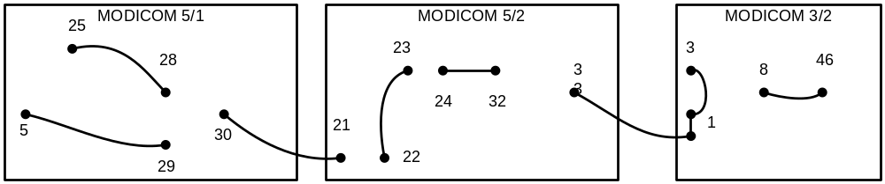

- Visualize the digital modulator in the oscilloscope. Draw the signal and indicate the following characteristics: V_{p-p}, voltage level associated with logic ‘1’ and logic ‘0’.
- Visualize the carrier in the oscilloscope. Draw the signal and indicate the following characteristics: V_{p-p}, frequency.
- Vary the position of GAIN adjustment fully clockwise and the CARRIER OFFSET and the MODULATOR OFFSET adjustments at the center point and draw the modulated signal.
- Repeat the step adjusting CARRIER OFFSET fully clockwise and the other two at the center point and draw the modulated signal.
- Again repeat the step adjusting MODULATOR OFFSET fully clockwise and the other two at the center point and draw the modulator signal.
- Using the three adjustments, try to obtain a modulated signal that is as close as possible to the ideal signal. Draw the modulated signal.
- Indicate the following characteristics of the modulated signal: Amplitude and Frequency of the signal corresponding to logic ‘1’ and logic ‘0’ (A1, f1 and A0, f0).

PART B: ASK DEMODULATION

Procedure:

1. Draw the signal at the following points:
- At the input of the MODICOM 5/2.
- At the output of the rectifier.
- At the output of the low pass filter.
- At the output of the DATA SQUARING circuit.

2. Check that the data generated in the MODICOM 3/1 are recovered in
MODICOM 3/2. For this, set the SYNC switches to ON.

Report:

- Submit all the wave shapes you observed at different test points, with your report. Discuss the nature of the wave shapes at different output levels. (Wave shapes should be plotted on graph paper.)
- What do you mean by ASK modulation of a carrier with unipolar and polar binary data?
- Briefly discuss the coherent and non-coherent detection of the ASK modulated signal. Which method is advantageous when considering the noise effect?
- When it is required to obtain the lowest probability of bit error when the input ASK signal is corrupted by Additive White Gaussian Noise (AWGN), what should be performed?
- What is the function of a Phase Locked Loop (PLL) circuit in product (coherent) detection?

References:

- MODICOM 5 manual.
- Modern Digital and Analog Communication Systems. -- B. P. Lathi
- Communication Systems. -- Simon Haykin
- Modern Communication Systems- Principles and Applications. -- Leon W. Couch II

